PHASE 4: MySQL Database Setup for Event Streaming

Step 1: Install MySQL on Windows

Download MySQL:
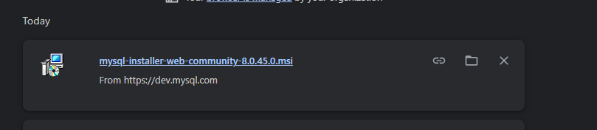

Installation Steps:
- Run the installer
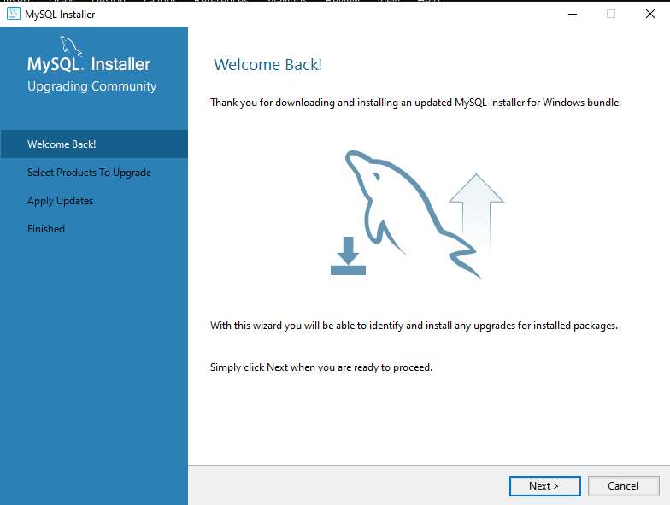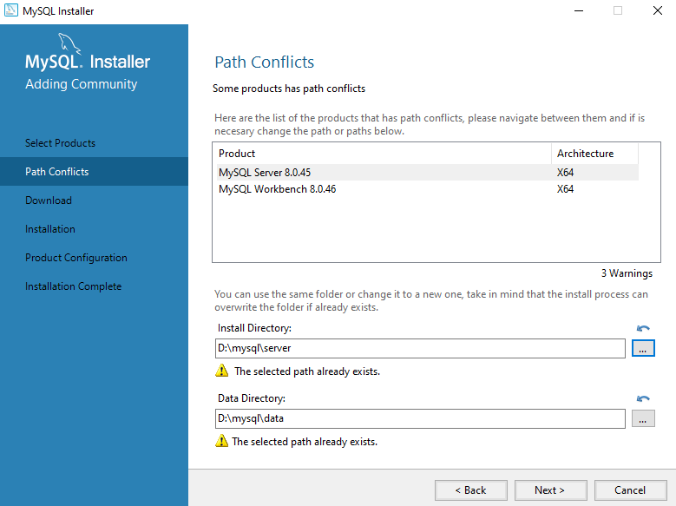
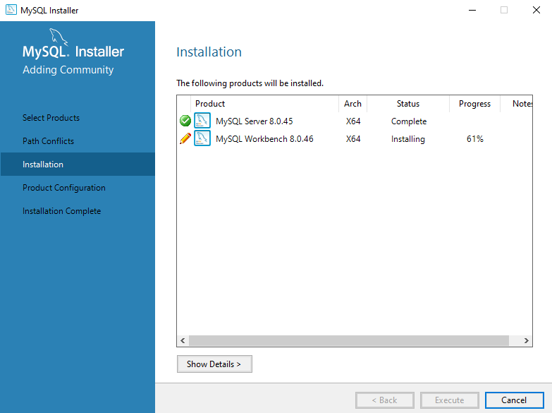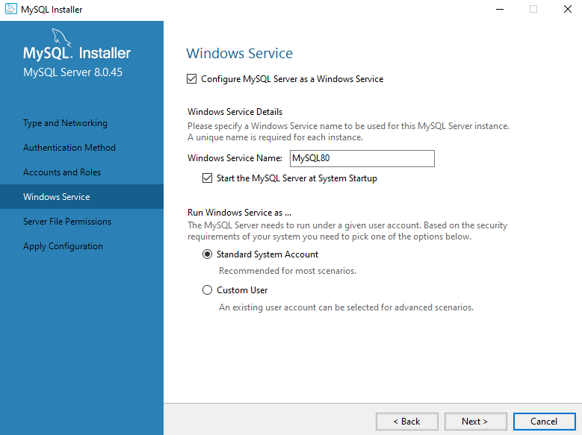
- Important: Set root password (remember it!)
  - Example: root123 or mysql123
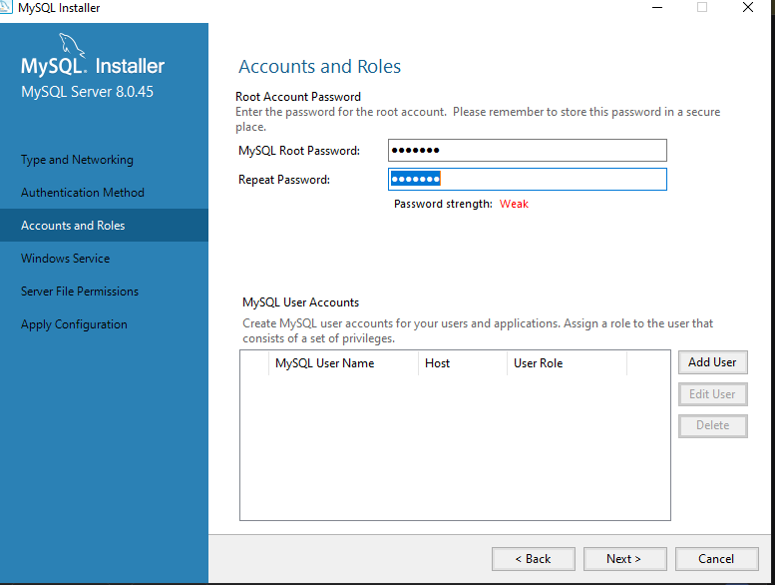
- Port: 3306 (default)
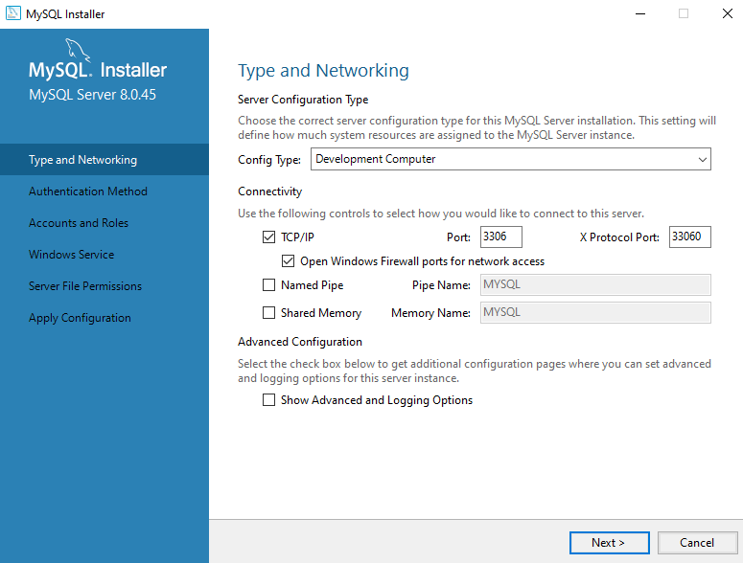
- Complete installation
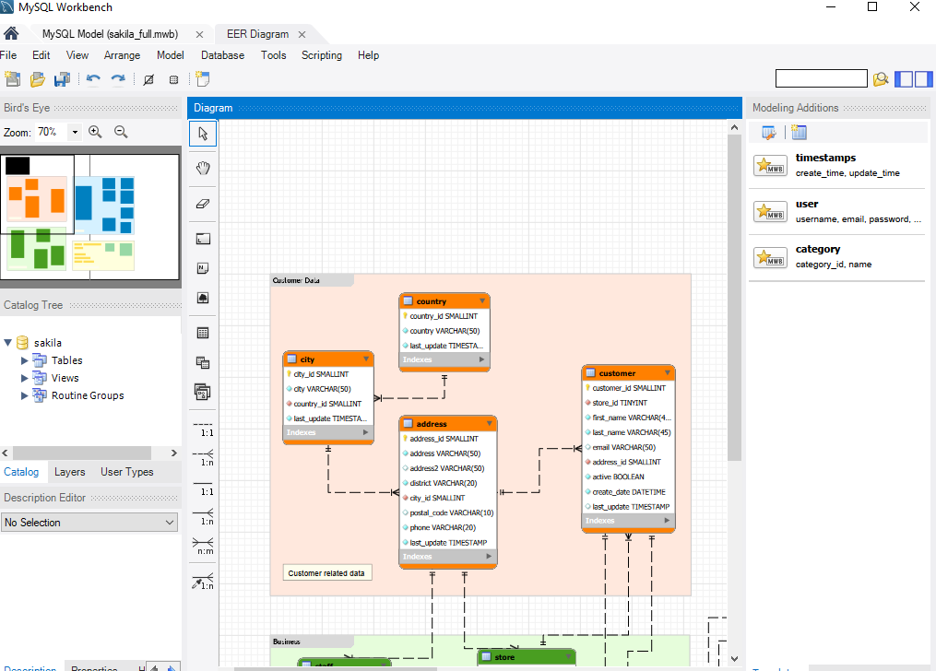

Step 2: Install MySQL Python Connector
- Activate virtual environment first
- Install MySQL connector
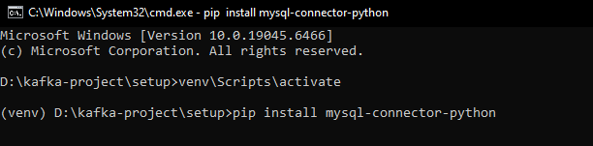
- Also install for async support

- Verify installation
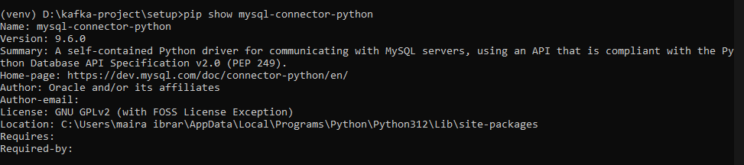

Step 3: Create Database and Tables
Create: D:\kafka-project\storage\mysql_schema.sql
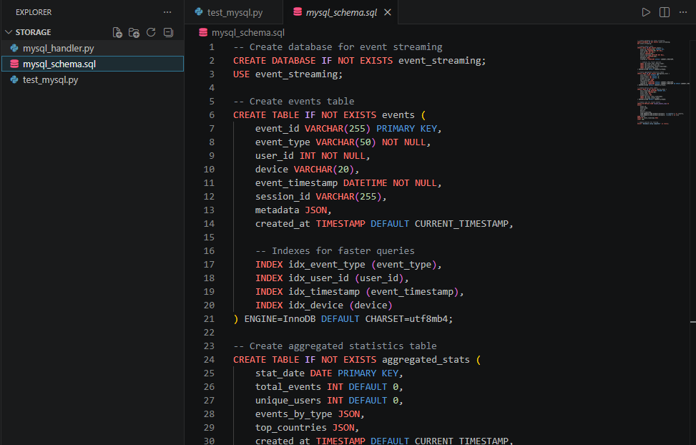

Step 4: Create MySQL Handler
Create: D:\kafka-project\storage\mysql_handler.py
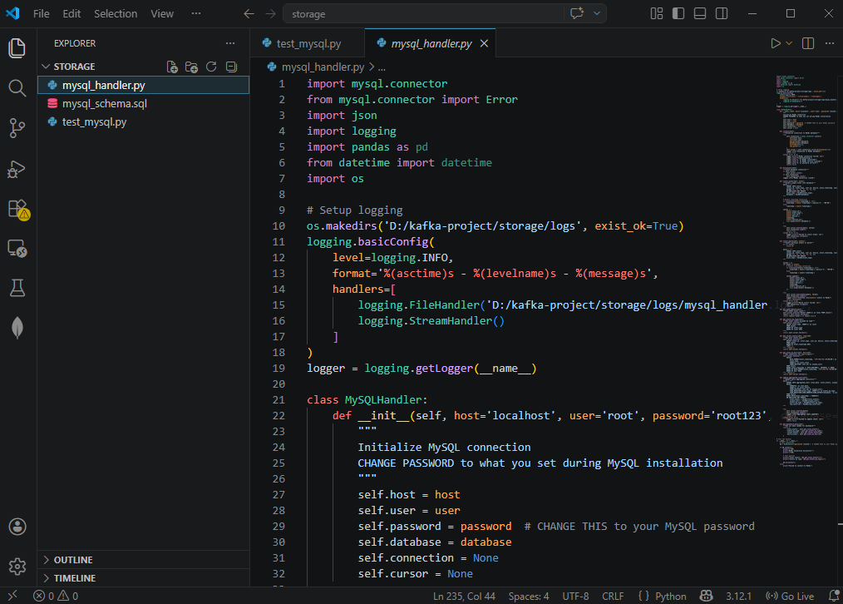

Step 5: Create Test Script
Create: D:\kafka-project\storage\test_mysql.py
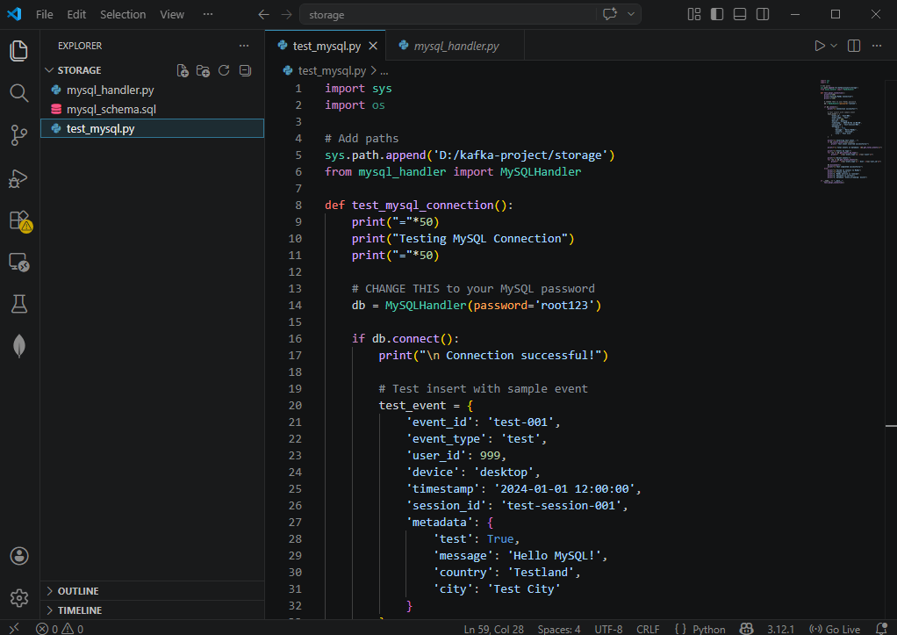

Step 6: Create MySQL Storage Consumer
Create: D:\kafka-project\consumers\consumer_mysql.py
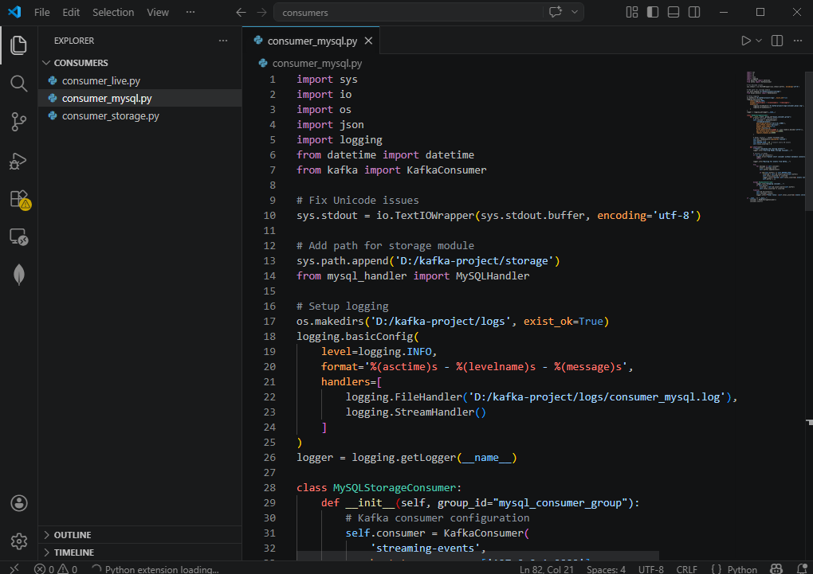

Step 7: Run the SQL Schema
- Open Command Prompt
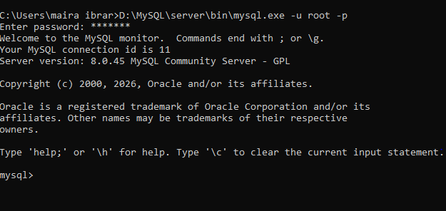
- Run the schema file
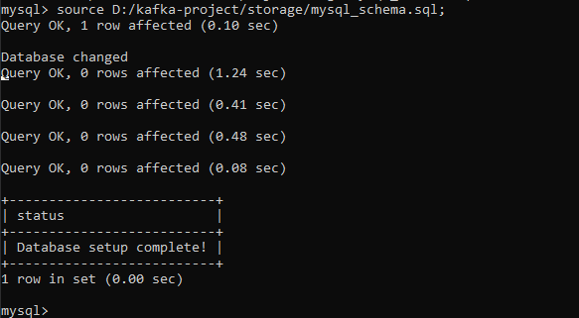
- Verify
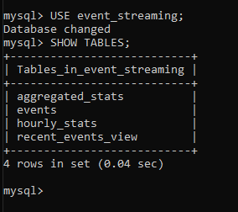

Step 8: Activate Virtual Environment and Install MySQL Package
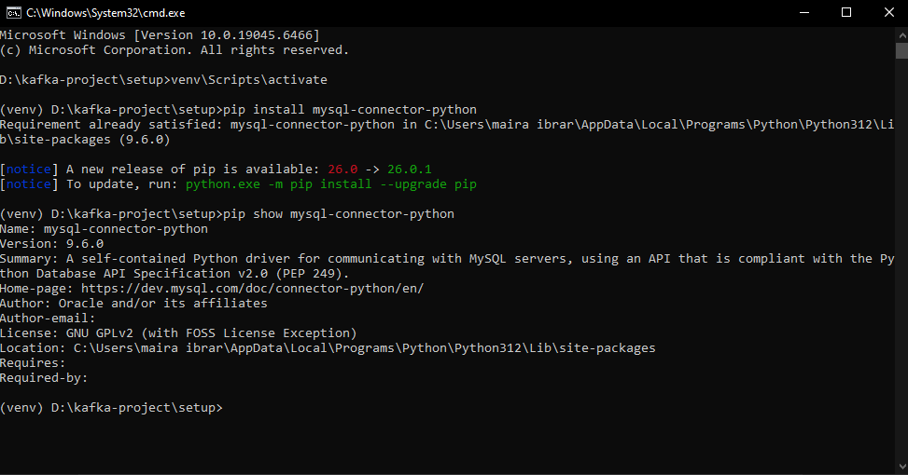

Step 9: Test MySQL Connection
Make sure venv is activated
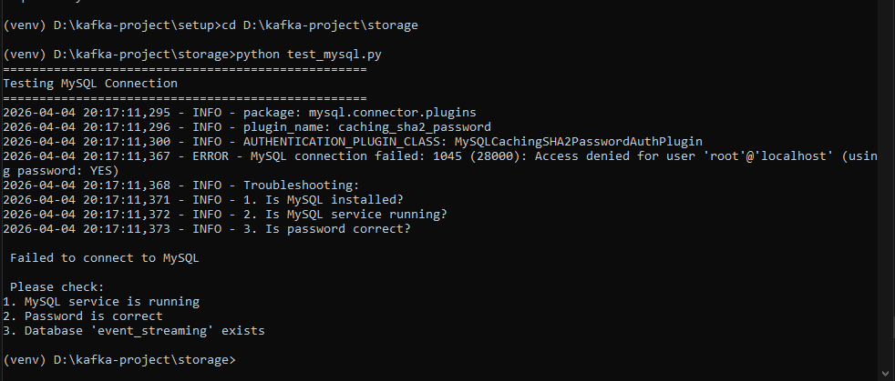

Step 10: Run Complete Pipeline
Terminal 1: Kafka
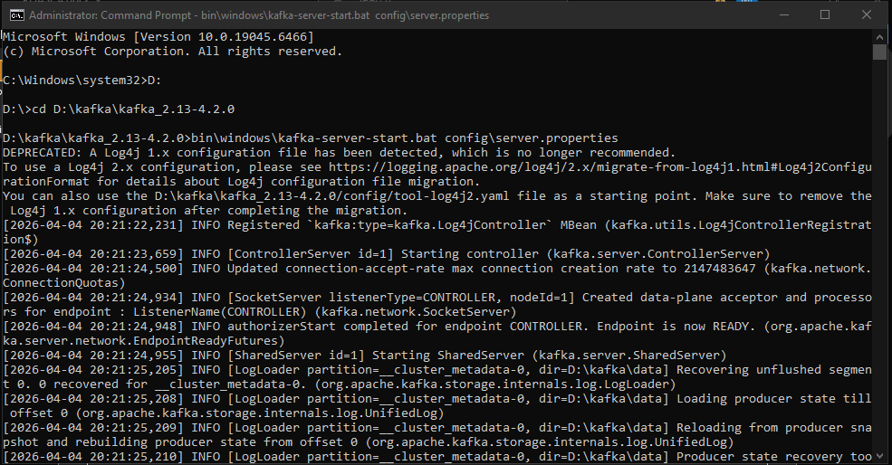
Terminal 2: Create Topic (one time)
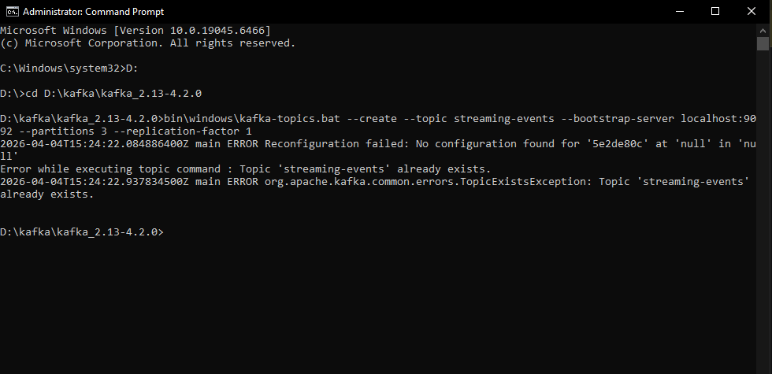
Terminal 3: Run Producer (activate venv first)
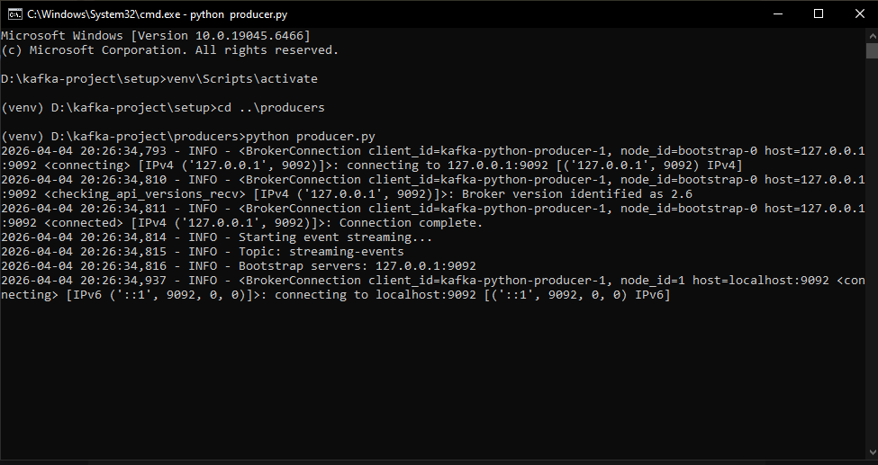
Terminal 4: Run Live Consumer
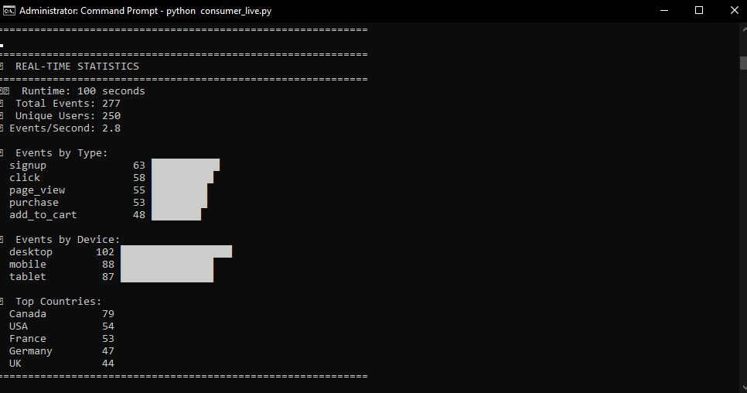
Terminal 5: Run MySQL Consumer
